**CS-213 Advanced Programming**



**Assignment # 01**

**Muhammad Ali Sadiq**

**BSCS 7A**

**210389**

**Submitted to: Dr. Sidra Sultana**

**Introduction to XOOPS:**

Xoops stands for “eXtensible Object Oriented Portal System”. The script started as a portal system, but later on it evolved into a more reliable and stable content management system that can be used for creating small or large community websites, corporate portals, blogs and many more.

Xoops is an easy to use dynamic content management system written in PHP with object oriented code. This makes it a perfect choice for developers who want to customize their websites. However, it is not necessary to be a PHP coder to easily build your site with Xoops as it is very easy for a beginner programmer to use it.

**Configuration:**

1. **Download and Extract:**

First of all, we have to download the zip setup file from the official website (Xoops.org).

Extract the contents of the file into the local server folder i-e Xampp

1. **Web Server:**

For hosting the web server, I have downloaded Xampp, which is an Apache based web server.

1. **Database Server:**

I am using MyPHP for this, I’ve created a database to connect to the site.

After completing the above steps, move the extracted zoops folder inside the htdocs folder inside xampp:

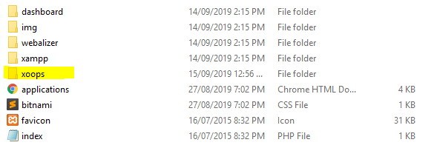

1. **Xoops Installation Wizard:**

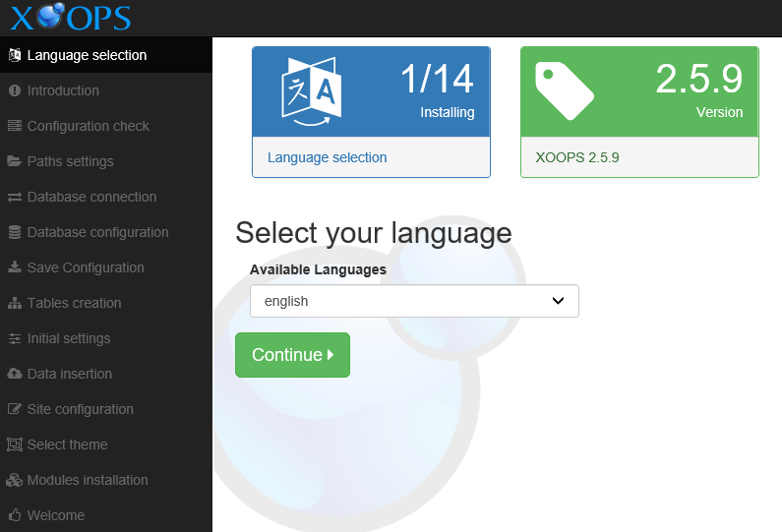

Open the extracted folder from the local host and run the installation Wizard.

It includes 14 steps to install Xoops

After the database has been connected and the installation is complete, it will show the main page.

